Microprocessor Suggestions

# Short Answer Type Question

1. Draw the timing diagram of the instruction LDA 9000H.

Ans. 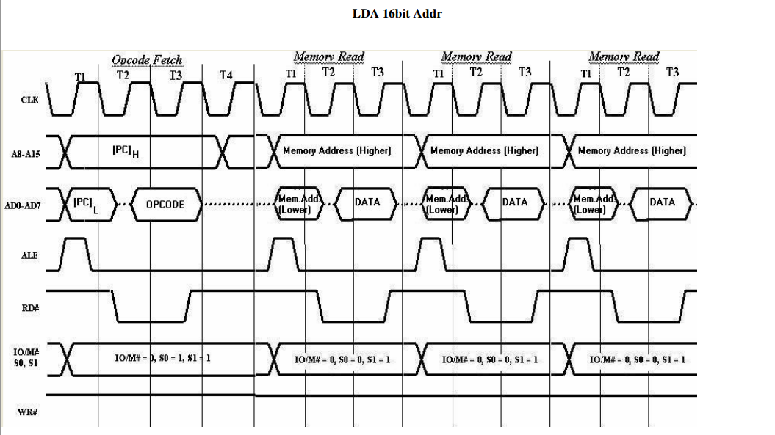

1. Write down a delay subprogram of 200 ms time duration for 8085 processor in ALP.

Ans. Given required delay = 200 ms.

8085 microprocessor is having a clock speed of 3.125 MHz.

Frequency = 3.125 x 106 sec-1

Thus time period for each clock pulse:  
 1/(3.125 x 106 sec-1) = 0.333 sec.

Then 200 ms = 200 x 10-3 sec.

Total number of T-States =

1. Write an instruction to move the contents of B-C pair at the top of stack.

Ans. PUSH B instruction can push the B-C pair content to the top of the stack. On executing the above instruction the content of B register is copied to the memory address pointed by the stack pointer, and then the stack pointer value is decreased by 1 and then again the content of C register is moved to the memory location pointed by the stack pointer.

1. Write an 8085 program to check if RST 5.5 is pending. If it is pending, enable it without affecting any other interrupts, otherwise return to the main program.

Ans.

|  |  |  |
| --- | --- | --- |
| OPCODE | OPERAND | COMMENT |
| RIM |  | Read the status of interrupts |
| MOV C, A |  | Save the status in C register |
| ANI | 10H | Check whether RST 5.5 is pending |
| JNZ | NEXT | If pending then jump to NEXT |
| RET |  | Return to the main program |
| NEXT : MOV A, C |  | Get the interrupt status in A register |
| ANI | FE | Set D0 = 0 for enabling RST 5.5 without effecting any other interrupts. |
| ORI | O8H | Set D3 = 1 for enabling interrupt enable flag. |
| SIM |  | Set the masks. |
| RST 3 |  | End |